title of the paper
A. B. Author^{1*} and C. D. Author²
¹Affiliation, Address, Country
²Affiliation, Address, Country
*Email: <email address of primary author>

Abstract: Papers must include an abstract. Abstracts should be between 200 and 300 words in length and should appear centred at the top of the paper with a 35 mm margin on the left and right. Starting the abstract with the paragraph heading "Abstract:" in 10 pt bold font. The remainder of the abstract should be in normal 10 pt font. The text in the abstract should be justified. The abstract of the paper should be usually in one well-developed paragraph, although some cases require multiple paragraphs. Do not indent the abstract. Do not cite references in the abstract. Avoid using abbreviations in the abstract. Note that the paper title must be in 12 pt bold Arial and the authors and their affiliations and primary email contact must be in 10 pt Arial. Note that the only abstract of the paper will be included in the printed version of the Proceedings to reduce the size of ISH 2015 Proceedings. For this reason, abstract should clearly summarise the main goals, technology and achievements of the research.

1 Introduction
First of all, the Organizing Committee reminds you that, the presenting author is required to complete the pre- registration for the ISH with full payment of the conference fee. The Organizing Committee encourages you to register through the official web page of ISH by May 31. 2015 for getting discount rate.
General instructions, guidelines and rules for the preparation of papers for ISH 2015 are included in this document.

2 GENERAL Instructions
Specific details are provided in the following sections.

2.1 Language and paper length
All ISH 2015 papers should be written in English. Papers are limited to six pages, including all text, references, figures and tables. Papers of more than six pages could not be accepted for publishing in the Proceedings.

2.2 Page layout
Paper size: Must be A4 (210 x 297 mm).
Columns: Papers must adhere to a two-column format, with each column width being 80 mm and the space between columns being 10 mm. The total text height should be 250 mm on all pages. The margin from the edge of the page to the text at the top, bottom, left and right should be 20 mm on all pages.
Pagination: Do not paginate your paper. Page numbers will be inserted later by the Proceedings publisher.
Paragraphs: Should be full-justified, i.e., both the left- and right-hand margins should be straight. Single line spacing should be used. There should be a single line space between paragraphs.
Font and font size: The font ‘Arial’ of size 10 points should be used throughout. For Greek letters and symbols, the font ‘Symbol’ should be used in Microsoft Word.
Important: The text should not include any company logos. References to commercial companies or organizations are allowed only to author’s address.

2.3 Miscellaneous
Units: Authors must use SI units and internationally recognized terminology and symbols.
Copyright: It is important to note that a paper that has been published previously will not be accepted into the Proceedings, even if the original publishers have granted permission. If a part of the work has been published elsewhere, recognition must be given in the paper by citing the reference.

3 DETAILED INSTRUCTIONS

3.1 Paper title
The title should be centred in all capitalised letters with bold Arial style of size 12 points, 20 mm from the top of the first page (see the template). The page justification should be one-column, centred as shown on the attached template. The left and right margins for the title, authors and affiliations must both be 35 mm.
Remove all traces of the template, which are only provided as a tool and should not appear in your final submission.
The paper title should preferably be the same as that one you provided when you submitted your abstract. If you need to change this title in the final paper, please notify the ISH 2015 Secretariat at:
secretariat@ish2015.org
One line below the title, the author(s)’s name(s), affiliation(s), hard copy correspondence address and e-mail address should be given with centred justification. The author(s)’s name(s) should be typed as capitalised words with normal style of size 10 points. Only the name(s), affiliation and mailing address should appear, not degrees, titles etc. An author’s name should include the first and middle initials followed by the surname. The name of the affiliation should be given in full and should not be abbreviated. If an author holds multiple affiliations, please include only a single primary affiliation. Only the e-mail address of the corresponding author should be given.
The paper abstract must follow the paper title and details of the author(s).

3.2 Main body
The text, in two-column page layout, is separated by two line spaces from the author(s)’s name(s), affiliation, address and paper abstract. Papers must not contain page numbers since this will be added during the publication phase of the Proceedings.
The following directions serve the purpose of obtaining a uniform layout.
Sections and headings: The paper is organized in sections, subsections, etc. These should be numbered as shown in the example paper and differentiated by means of headings of different rank. All headings must be based on a 10 point Arial font.
First-rank (or main) headings: These start at the left-hand margin with a numeral and must be typed in bold capital letters. Except for the start of the text and the top of a new column, a first-rank heading is preceded and followed by single-line spacing.
Second-rank (or sub) headings: These start at the left-hand margin with the main section numeral followed by the sub-section numeral. Except for the first letter, all letters should be bold lower case and are preceded and followed by single-line spacing.
Third-rank (or minor) headings: These start at the left-hand margin, and are in italics. Except for the first letter, all letters should be lowercase. As with the other headings, they should be preceded by single-line spacing, but the text should follow the heading on the same line after three character spaces (see the following example).
3.2.1 Minor Heading
This is an example of the third-rank (or minor) heading.
Footnotes: Footnotes should be avoided. If it is really necessary to use them, they should be written at the bottom of the page below the text body. Footnotes are to be separated from the text body by two lines of space, and a line drawn across the column. The footnote is typed below this line using the same font and font size as in the main text.
Equations: Equations should be consecutively numbered with Arabic numbers in parentheses, placed at the right-hand margin, for example:
V = I ⋅ R (1)
where: V = Voltage in Volt (V)
I = Current in Ampere (A)
R = Resistance in Ohm (Ω)

References: These should be given in the text as [1]. For multiple citations, the numbers must be included in square brackets, for example [1-3, 5]. If a work is cited more than once in the text, the same reference number should be used on every subsequent occasion. A numerically ordered list of references should be placed at the end of the paper typed in single line spacing.
The format for references is (see end of this template):
Reference number in square brackets [x], Name of author(s), “Title of the article”, the abbreviated name of the journal/conference, the volume number, the page numbers, year of publication.
Authors are encouraged to avoid using online references where ever possible. If this is not possible it is important to include as much information as possible, most important is the date of last access [2].
Tables: These should be self-contained and numbered consecutively. Use Arial 10 point font for the caption. Some tables may take up the full width of a page and should then be placed at its top or bottom. Please type headings above the tables – for example refer to Table 1.
Table 1: An example table
Parameter | Max | Min | Average | Std. Dev
Voltage in kV | 19.0 | 11.0 | 15.0 | 1.0
Current in A | 8.0 | 6.0 | 7.0 | 1.4
Power in kVA | 152 | 66 | 105 | 1.2

Figures: Figures should be inserted in the text and should be original. Use Arial 10 point font for the caption. Some figures may take up the full width of a page.
Each figure should have a figure number and caption that should be written right under the figure. The figures should be referred to the text as “Figure x”.
Figures, including explanatory text and the caption, should preferably be prepared to observe the text layout – for example refer to Figure 1.
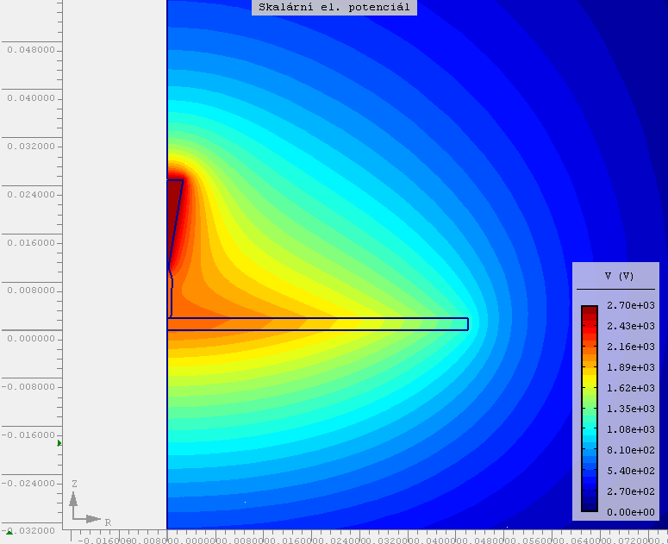
Figure 1: Field distribution
Column balance: Where possible, authors should balance the columns on the last page of the paper – in Word this will have to be done manually.

4 DUE DATE AND SUBMISSION DETAILS
The deadline for submitting of the full papers is April 15, 2015. Regarding to the very tight schedule for reviewing and preparing the papers for the final conference programme, papers submitted after April 15, 2015 are likely to be rejected. Please ensure the submission of your paper in due time.

5 Conclusion
This paper has provided guidelines to submit final papers to ISH 2015. Please make an effort to adhere to these guidelines as the quality of the Proceedings (book of abstracts and USB flash disk for full paper contribution) depends on you. Thank your for your co- operation and contribution.
It is highly recommended that you use the present document as a model, and even as a starting point for your final paper, and ultimately convert this to a PDF file which you will submit using the online system which will be available soon. Note that only PDF versions of the full paper could be accepted.
Your final paper will only be accepted after approval of the ISH 2015 Scientific Committee.
Thank you for your assistance and we look forward to welcoming you in Pilsen, Czech Republic, in August 2015.
ACKNOWLEDGMENTS
Authors may wish to acknowledge sources of funding, etc.
REFERENCES
- M. Hinow, W. Hauschild, E. Gockenbach: “Lightning Impulse Voltage and Overshoot Evaluation Proposed in Drafts of IEC 60060-1 and Future UHV Testing”, IEEE TDEI, Vol. 17, No. 5, pp. 1628-1634, 2010.
- A. Author. Title of work, January 2015. Available from: http://www.xxx.yyy/article.html, last accessed: January 10, 2015.

